Step 1: Choose at least one of the models below to create for the given scenario.

Step 2: Share and discuss your model.

Step 3: Create the remaining models.

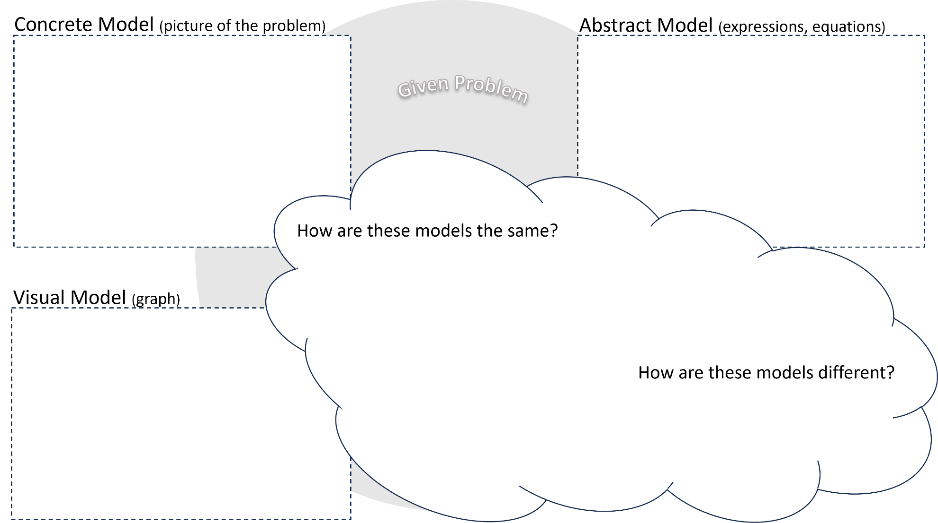

What is the best model to use for the given scenario? Why?

Step 4: Use the models to help you solve the problem. Record your process below.

Step 5: Share and discuss your solution process.

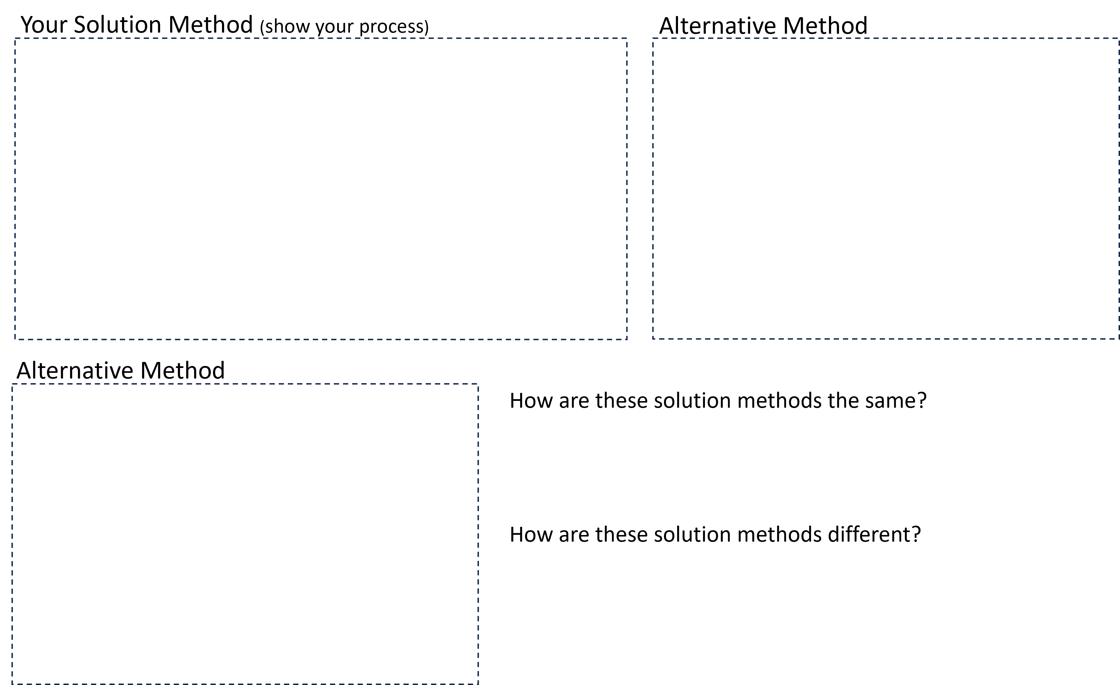Step 6: Record other solution methods.